BPD Mobile Application Recreate Database Setup

# Recreate Database

Before you recreate the database, first make sure that you have started the database. Second, make sure that you do not have an open connection to the database as the BPD_MOBILE user (if you have a connection open using the BPD_MOBILE user, the first script will throw an error). If SQL Developer is not opened, then you are good to go. If SQL Developer is opened, right click on the BPD_MOBILE connection, and click disconnect. Afterwards, perform the following:

1. Navigate to the directory named C:\temp\BPD_DatabaseFiles\ on the machine that you have the oracle database installed.
2. Copy the files that were attached to the email (or from the Google Drive) to this directory. The files should be:
   1. 1a_DROP_USER.SQL
   2. 1b_CREATE_USER.SQL
   3. 2_DDL.SQL
   4. 3_ALL_DATA.SQL
3. Open a command window (you can do this by typing cmd in the windows search window . Depending on the operating system you used, you may have to search for the command window a different way (I am using Windows Server 2012): 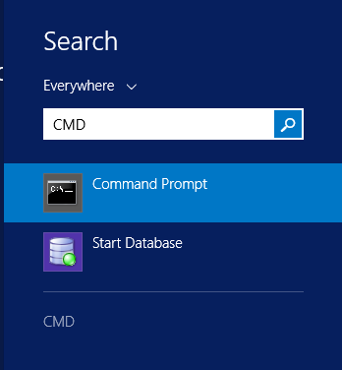
4. Select the Command Prompt
5. Navigate to the C:\temp\BPD_DatabaseFiles directory: 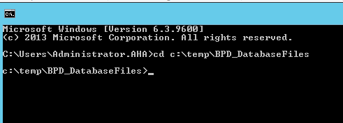
6. Access SQL Plus.
   1. Type in sqlplus / as sysdba 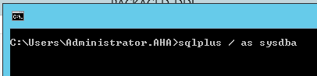
7. You should get the following (if you don’t then we have a problem): 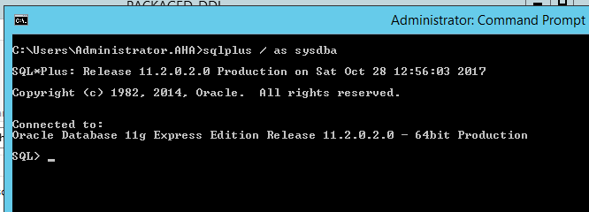
8. Run the drop user script:
   1. Type @1a_DROP_USER.SQL and press Enter
9. Run the create user script:
   1. Type @1b_CREATE_USER.SQL and press Enter
10. Run the ddl script:
    1. Type @2_DDL.SQL and press Enter
11. Run the data script:
    1. Type @3_ALL_DATA.SQL and press Enter
12. After all scripts have executed, if you do not have SQL Developer opened, open SQL Developer and connect using the BPD_MOBILE user. If SQL Developer is already opened, just reconnect using the BPD_MOBILE user.
13. After you have connected to SQL Developer with the BPD_MOBILE user, you will need to recompile the triggers, as some may be invalid. Just right click Triggers, select Compile Invalid, click OK a couple of times, and you should be finished.